# Exp No: 1 Date:16.07.2024

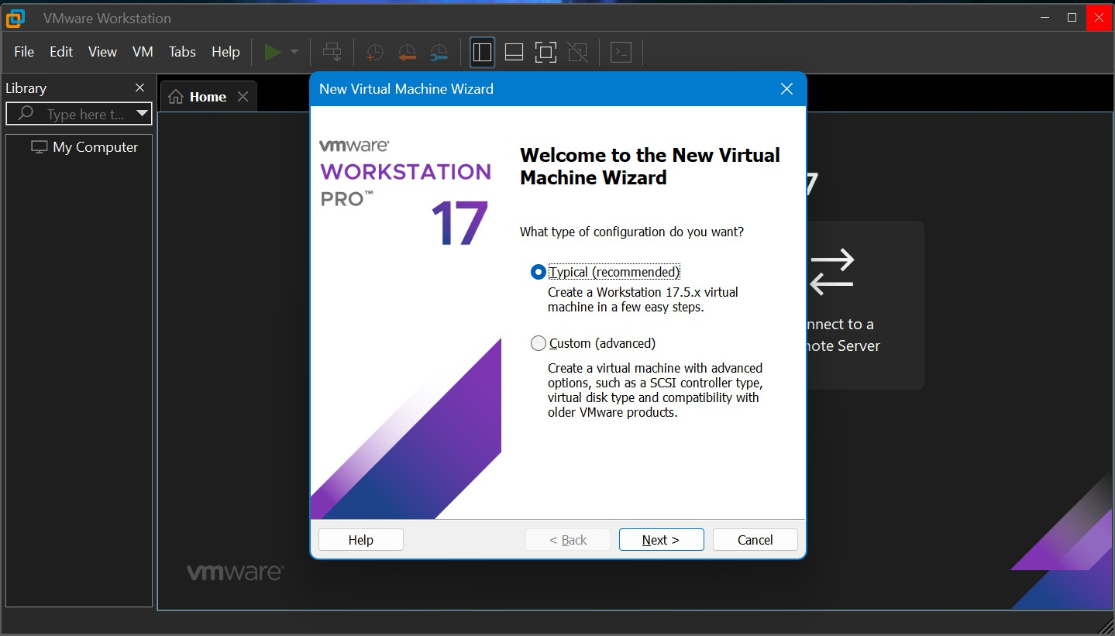

# Reg.No: 210701321

VIRTUALIZATION

**CONFIGURATION AND CREATION OF VIRTUAL MACHINE**

# AIM:

To configure a Virtual Machine using VMware and Launch the VM and execute a

simple program using C/PYTHON/JAVA.

# PROCEDURE:

1. Launch a VM ware
2. Create new virtual machine
3. Customize the set-up
4. Set usemame and password
5. Browse for .iso file of an operating system
6. Configure the hardware capacity
7. Finish and power on the VM
8. Install C or PYTHON OR JAVA Compiler and execute a simple program

# OUTPUT:

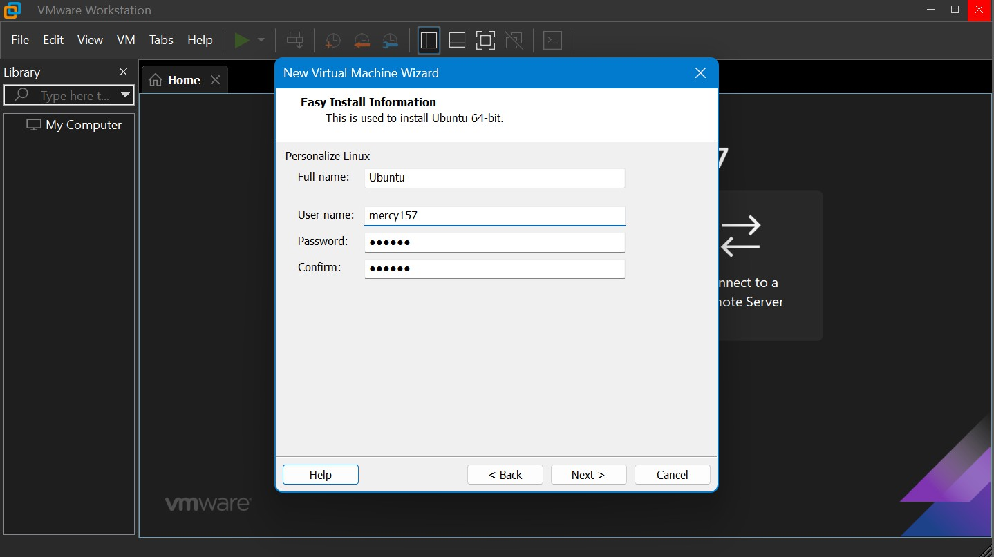

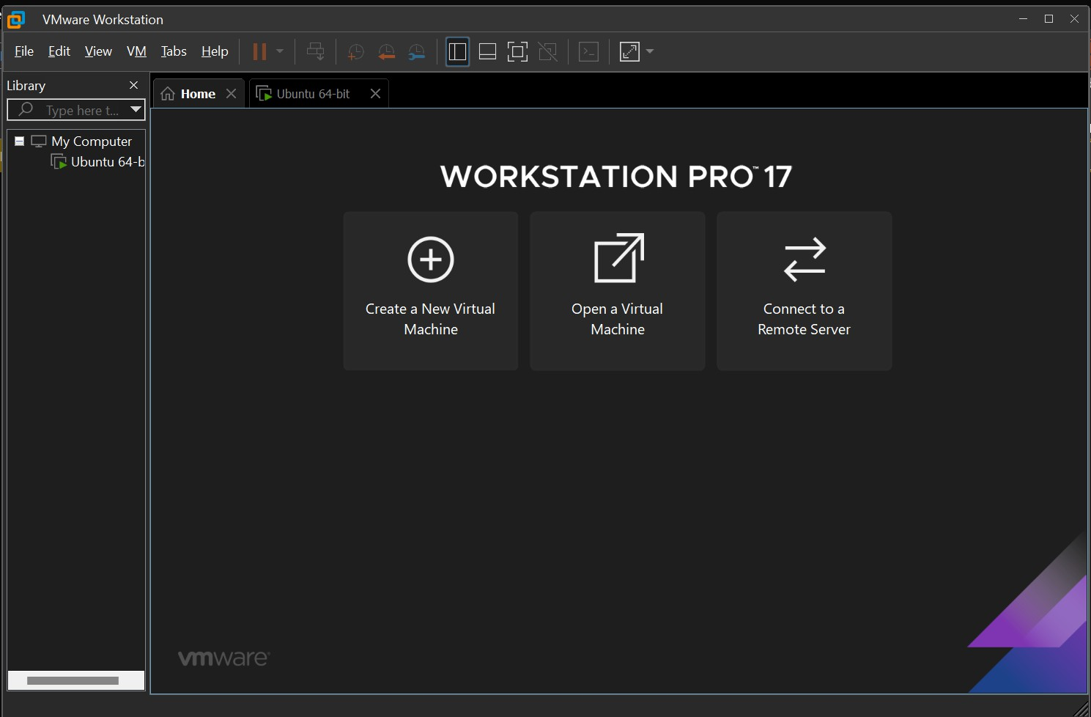

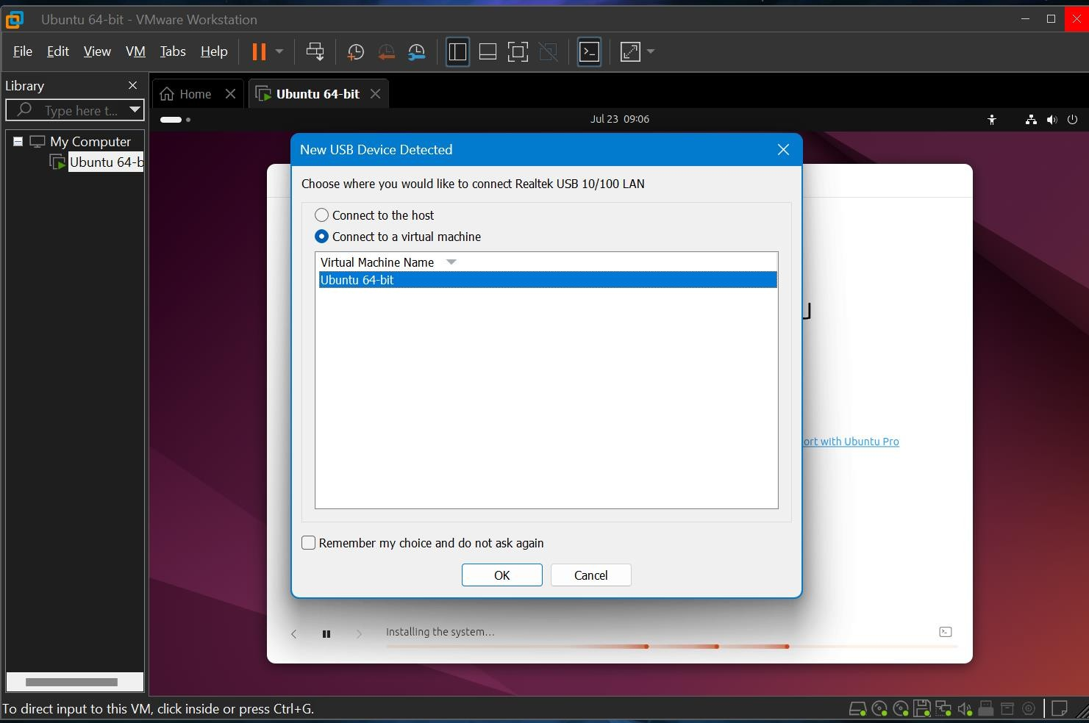

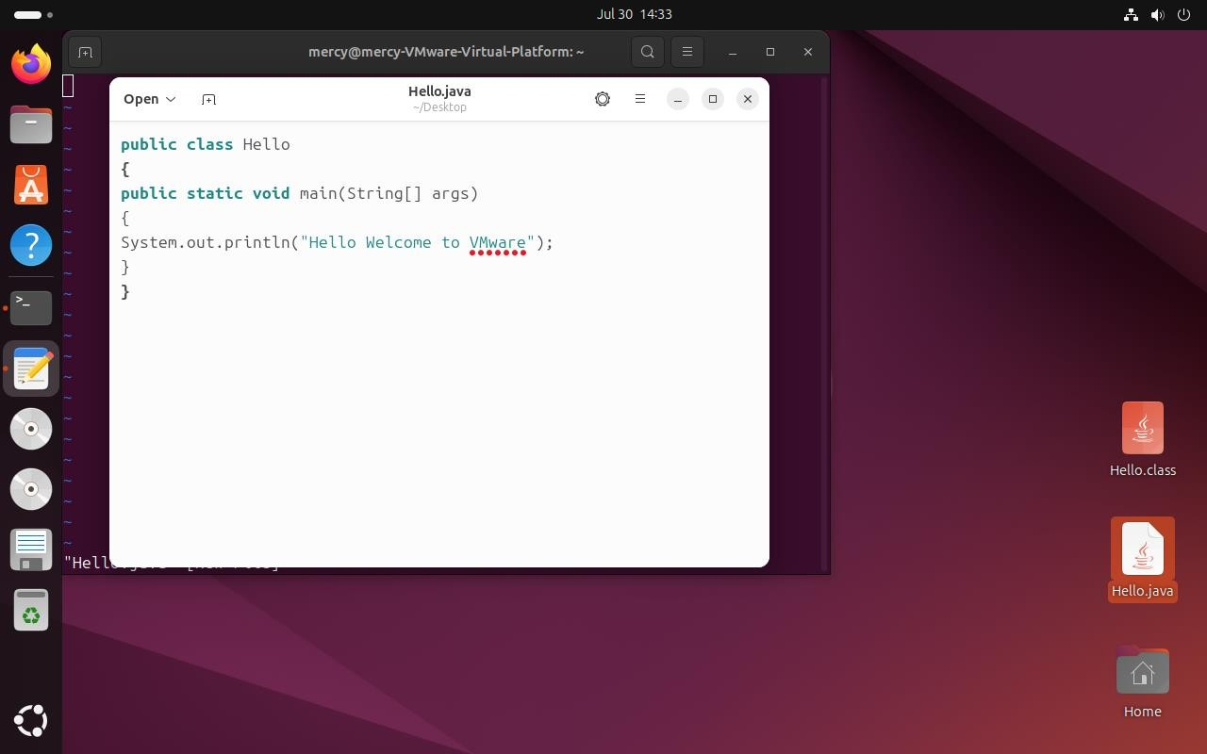

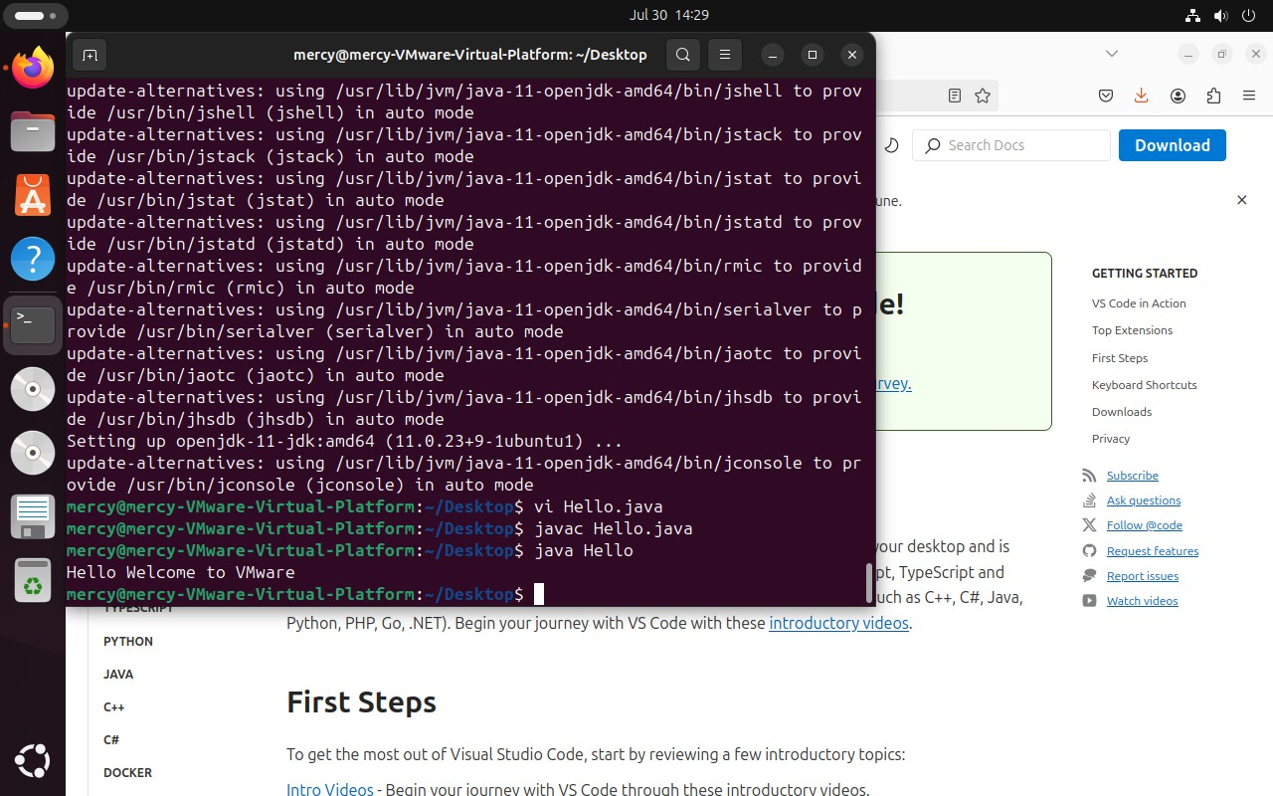

**RESULT:**

Thus the configuration of virtual machine using VMware and execute simple java program has been completed successfully.